Jedburgh Medical Practice

Telephone No. 01835863361

Website: www.jedburghmedicalpractice.co.uk

**Jedburgh Medical Practice Provides Primary Care Services to the following areas:-**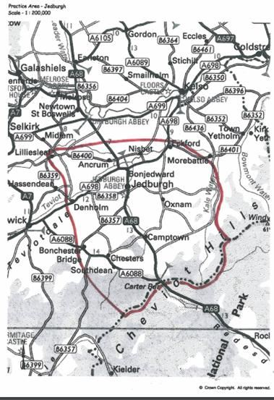

If you live out with this area please speak to one of our Patient Advisors who will provide you with information on how to move to a practice closer to where you live.

**When we are closed**

When the practice is closed, if you urgently need medical help or advice and it is life threatening, dial 999. If it is not life-threatening, contact NHS 111 by calling 111 or accessing via [www.nhs.uk](http://www.nhs.uk)

**Appointments and accessing practice services**

To make an appointment to see your GP or any member of our healthcare staff or to access any other of our practice services, please **call at 830am**.

The practice website contains all the relevant practice information that you are likely to require. It is the quickest way to access the services you may need.

**Prescriptions/repeat prescriptions**

Your GP will initiate any prescription that they determine you require. Repeat prescriptions can be ordered in the following ways:

* In person – By ticking the required medications on your prescription and posting it through the postbox.
* By telephone – Please call the practice on 01835863361 **after 11am**
* Online – Please log in and order via our website.

**Please allow 48 hours for collection (excluding weekends and bank holidays) when ordering repeat prescriptions.**

**Home visits**

Home visits are at the discretion of the GPs and are usually for those patients who are housebound or have significant health issues. Should you require a home visit, please use the practice website to request one or contact reception requesting a call-back after logging a call before 10am. A clinician will then telephone you to discuss your request.

**Patient data**

All clinical and administrative staff have an ethical as well as a legal duty to protect patient information from unauthorised disclosure and in accordance with UK GDPR.

The patient privacy notice is available on the practice website

**Comments, suggestions and complaints**

If you would like more information about any of the services we provide, please ask a member of staff, telephone or log into the practice website. Details are shown on the front of this leaflet.

Our aim is to give the highest possible standard of service. We would like you to tell us what you think about the service we provide.

**Opening hours**

|  |  |  |
| --- | --- | --- |
| Mon–Thur | 8:30 am | 6:30 pm |
| Friday | 830am | 530pm |
| **GP’s In the Practice** | | |
| Monday | Dr Macintyre  Dr Mitchell  Dr Ferguson  Dr Galliano (Fellowship) | |
| Tuesday | Dr Macintyre  Dr Mitchell | |
| Wednesday | Dr Macintyre  Dr Ferguson | |
| Thursday  Friday | Dr Ferguson  Dr Mitchell  Dr Macintyre  (every 2nd Friday)  Dr Galliano (Fellowship) | |

Here at Jedburgh we are currently providing medical care to around 7000 patients, and currently have 3 GP partners within the practice, this means our GP’s are currently caring for over 2300 patients each. This is unfortunately due to a nationwide shortage of GP’s, 28% of GP practices in the UK currently have at least 1 GP vacancy with as many as 225 full-time equivalent vacancies across GP practices in Scotland. There is currently a 15-20% increase in demand from patients to see a GP, which equates to an extra 3.1 million patients being registered across the UK but 343 less fully qualified family doctors.

As a result of this there may be times when we have to operate on emergency appointments only. We appreciate the frustration that this may cause and would like to thank all our patients for your understanding at this challenging time.

To ensure we are still able to provide a high level of care we have increased our team of Primary Care Service Providers who depending on your needs will be able to help you. Please continue reading so that we can introduce you to our primary care team.

**Our Primary Care Service Team**

All of our clinicians are highly trained and our patient advisors have been fully trained to be able to direct you to the most appropriate clinician for your needs. Our team consists of:-

**1 Advanced Nurse Practitioners**:-

Emma Brown

2 Trainee Advanced Nurse Practitioners: _

Lynne Finlayson and Berenice Lindores

**Mental Health Nurse** - Kirsty Harris

**Physiotherapist** – Laura Mabon

**2 Practice Nurses** – Angela Leitch and Lauren Elliot

**2 Health Care Assistants** – Vicky Colvine

We also have a team of 7 patient advisors here to answer your calls. You can help us ensure everyone who needs an appointment can get one by:-

* Providing our patient advisors with information allowing them to direct you to the correct clinician
* Cancelling your appointment if you can’t make it
* Informing us if you have moved out with the area so you can be moved to a practice nearer you.

**Staff Abuse**

Did you know over three quarters of GP practice staff face verbal abuse from patients each week

Our staff work hard to provide you with the best possible service. Please treat them with the courtesy and respect they deserve. We operate a zero-tolerance policy and may refuse to provide services to individuals or those accompanying individuals who are violent, threaten violence, commit or threaten to commit a criminal offence

**Further information can be sought from** [**www.nhs.uk**](http://www.nhs.uk)

.